202001421 Lab 2

1: Display ticket id for maximum ticket amount.
SELECT ticket_id FROM ticket WHERE amount = (SELECT MAX(amount) FROM ticket);
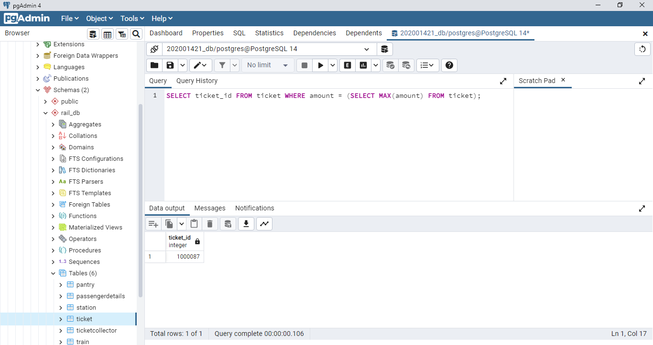
1 row

2: Print the Name of female passengers in descending order of passenger_id.
SELECT name, passenger_id FROM passengerdetails WHERE gender = 'female' ORDER BY passenger_id DESC;
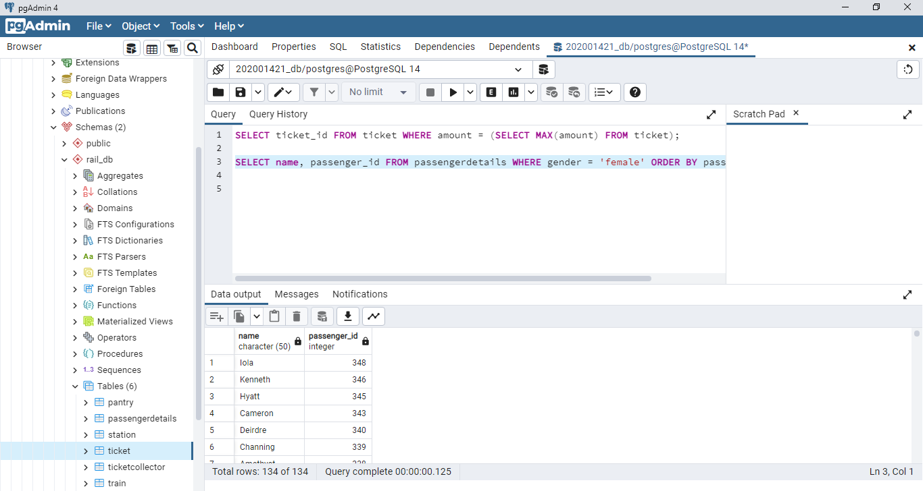
134 rows

3: Print ticket id of the highest 2 amounts of tickets.
SELECT ticket_id from ticket WHERE amount in ( SELECT amount FROM ticket ORDER BY amount DESC LIMIT 2);
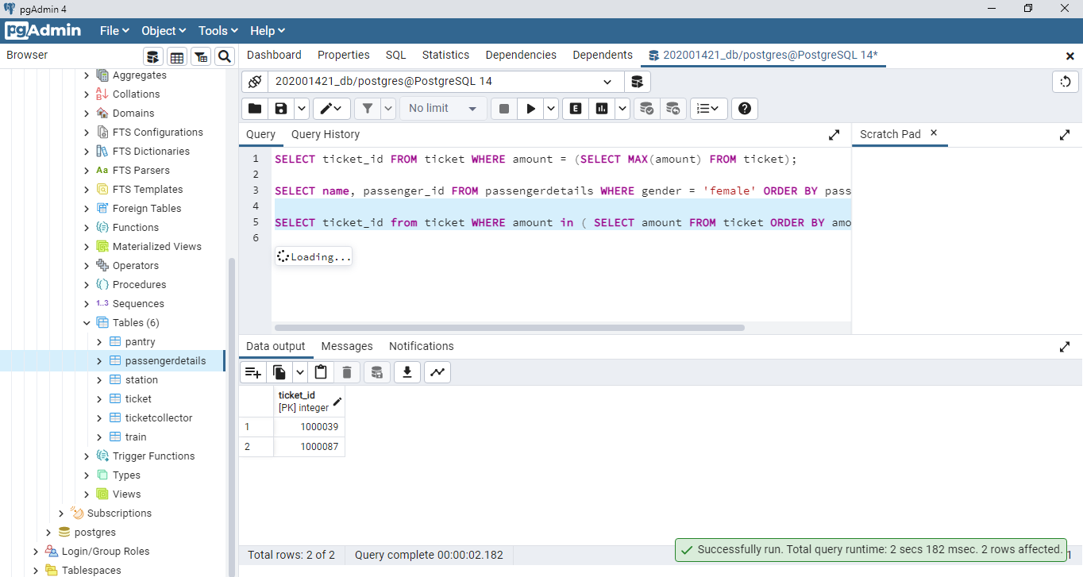
2 ROWS

4: Print count of passengers who did the payment of food in cash.
SELECT COUNT(distinct(passenger_id)) FROM pantry WHERE payment_mode = 'cash';
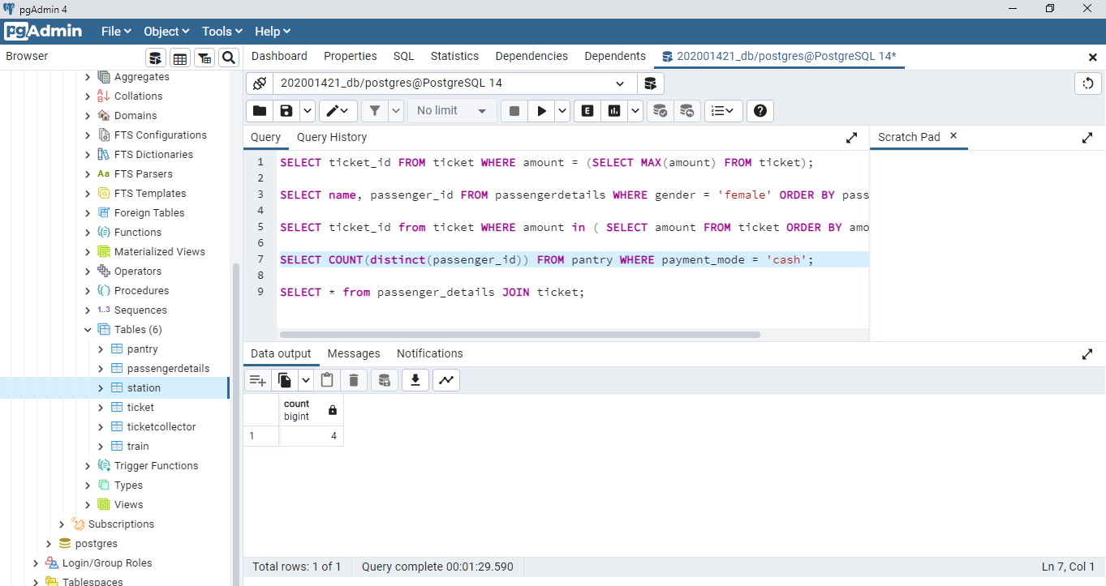
1 row

5: Print Passenger id and gender of the passengers whose ticket amount is greater than avg amount value.

SELECT passenger_id ,gender from passengerdetails NATURAl JOIN ticket WHERE amount > (SELECT AVG(amount) FROM ticket);
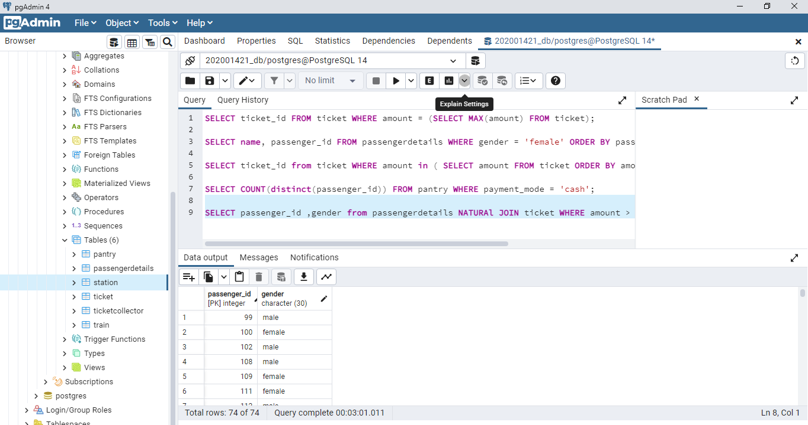
74 Rows

6: Find the station id and the train name arriving at that station.
SELECT station_id, train_name FROM train JOIN station ON station.train_id = train.train_id;
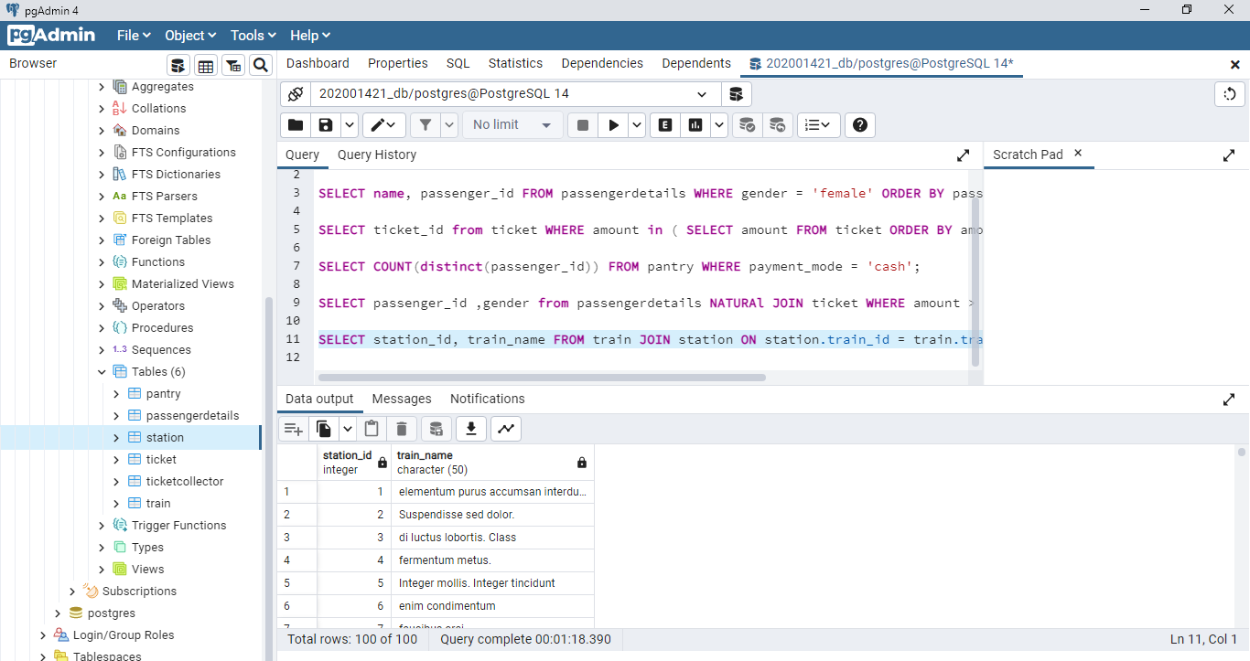
100 rows

7: Print the count of different types of transactions

SELECT COUNT(payment_mode), payment_mode FROM pantry GROUP BY payment_mode;
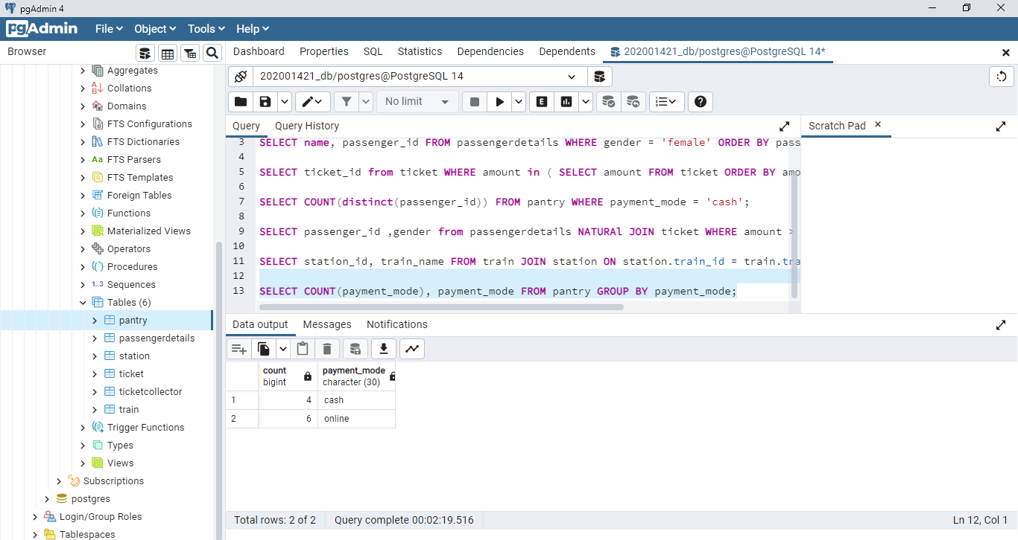
2 ROWS
8: Find the id of ticket collectors whose age is less than avg age.
SELECT DISTINCT(tc_id ) FROM ticketcollector WHERE age < (SELECT AVG(age) FROM ticketcollector);
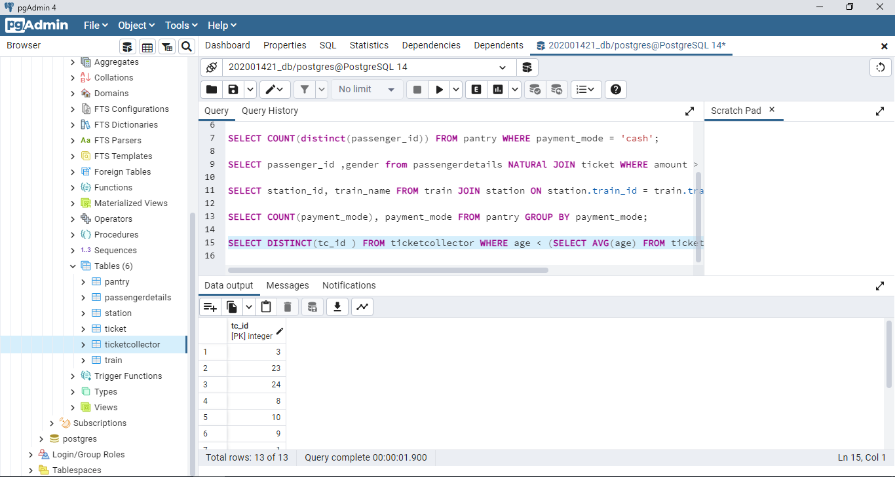

13 rows

9: Find the names of trains which are taking a halt at a station and sort in order of station id.
SELECT train_name FROM train JOIN station ON station.train_id = train.train_id WHERE hault = 'Yes' ORDER BY station.station_id;
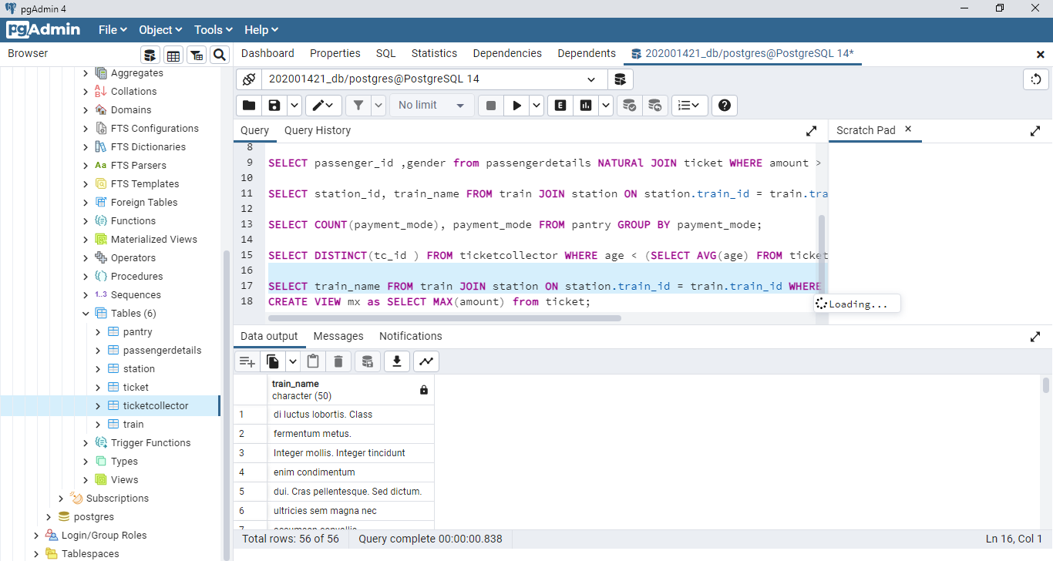
56 rows

10: Create a view of the maximum amount.

CREATE OR REPLACE VIEW mx as SELECT MAX(amount) from ticket;
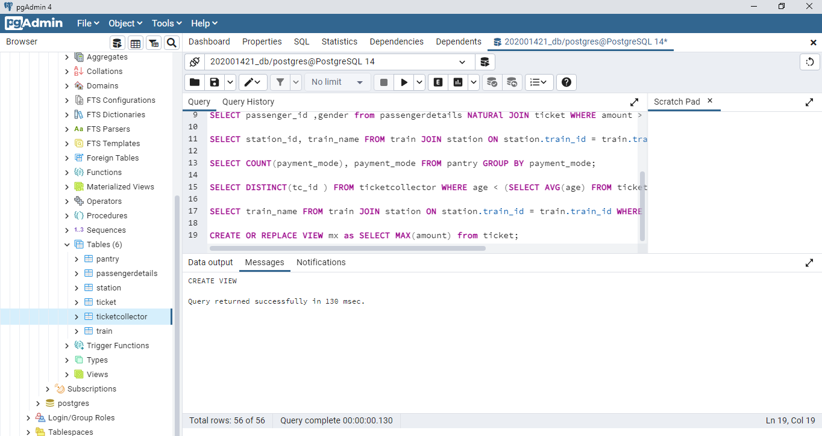

11: Create a view for station details then insert and display some new station ids to the
recently created view.

CREATE OR REPLACE VIEW station_details as (SELECT * from station);
INSERT INTO station_details VALUES('101','Z5T 3C4','08:45:00','106','Yes');
SELECT * FROM station_details WHERE station_id = 101;
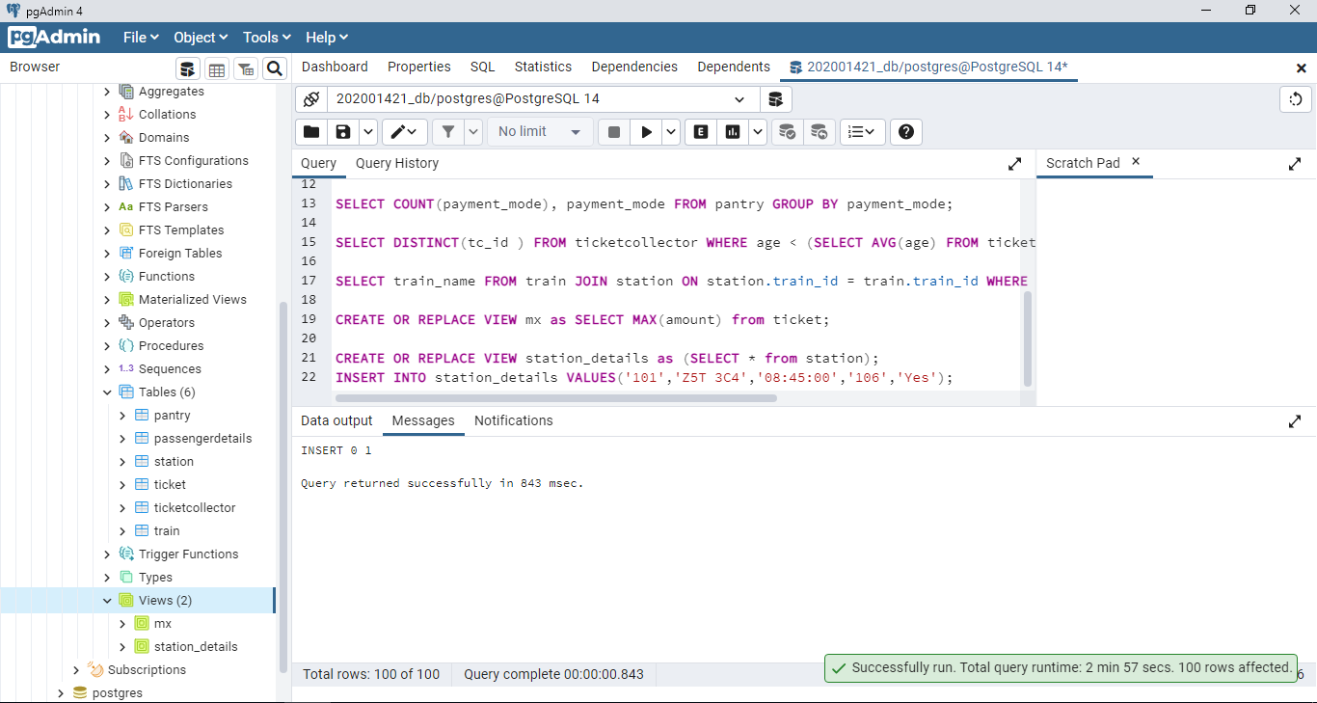
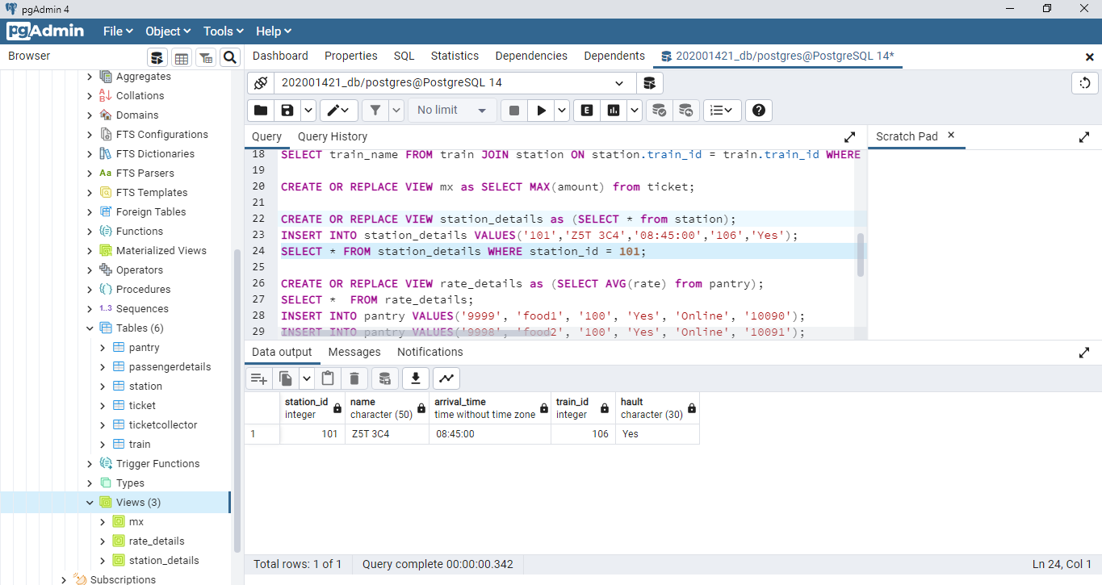

12: Create a view of the rate and put the average there. add 4 more food items to the pantry table and then display the contents of the view with the updated values.
CREATE OR REPLACE VIEW rate_details as (SELECT AVG(rate) from pantry);
SELECT * FROM rate_details;
INSERT INTO pantry VALUES('9999', 'food1', '100', 'Yes', 'Online', '99');
INSERT INTO pantry VALUES('9998', 'food2', '100', 'Yes', 'Online', '102');
INSERT INTO pantry VALUES('9997', 'food3', '100', 'Yes', 'Online', '101');
INSERT INTO pantry VALUES('9996', 'food4', '100', 'Yes', 'Online', '100');
SELECT * FROM rate_details;
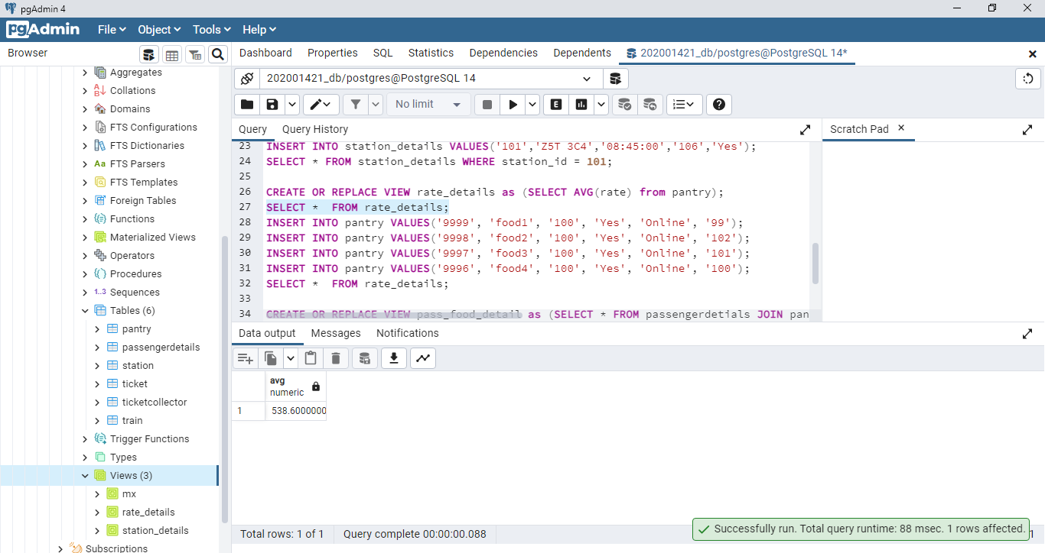
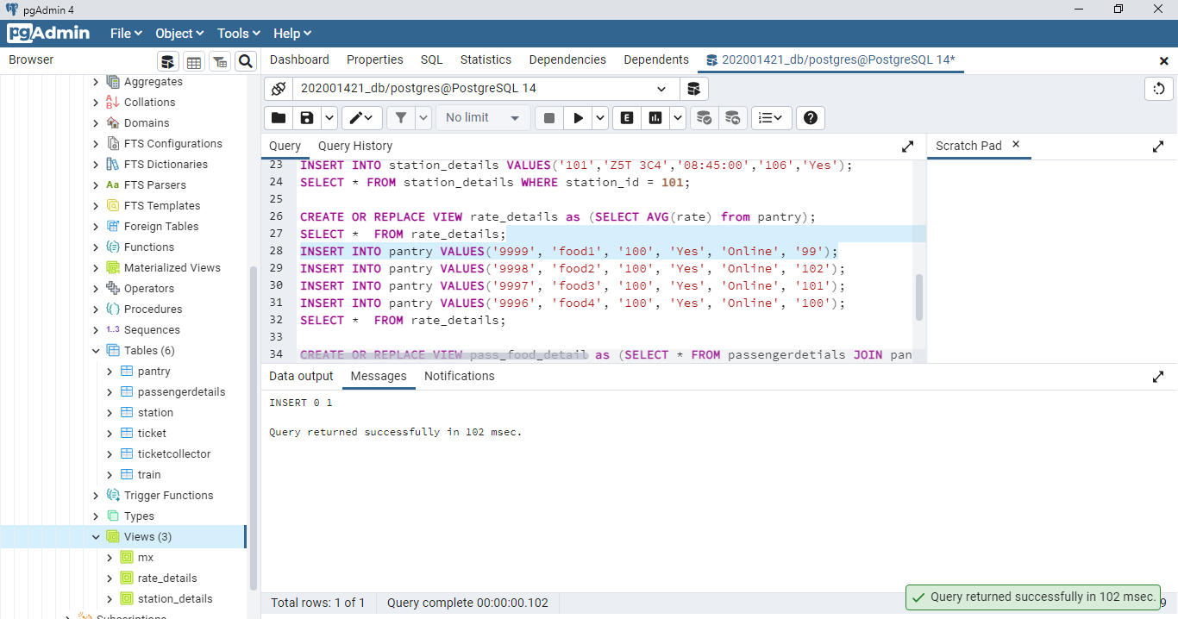
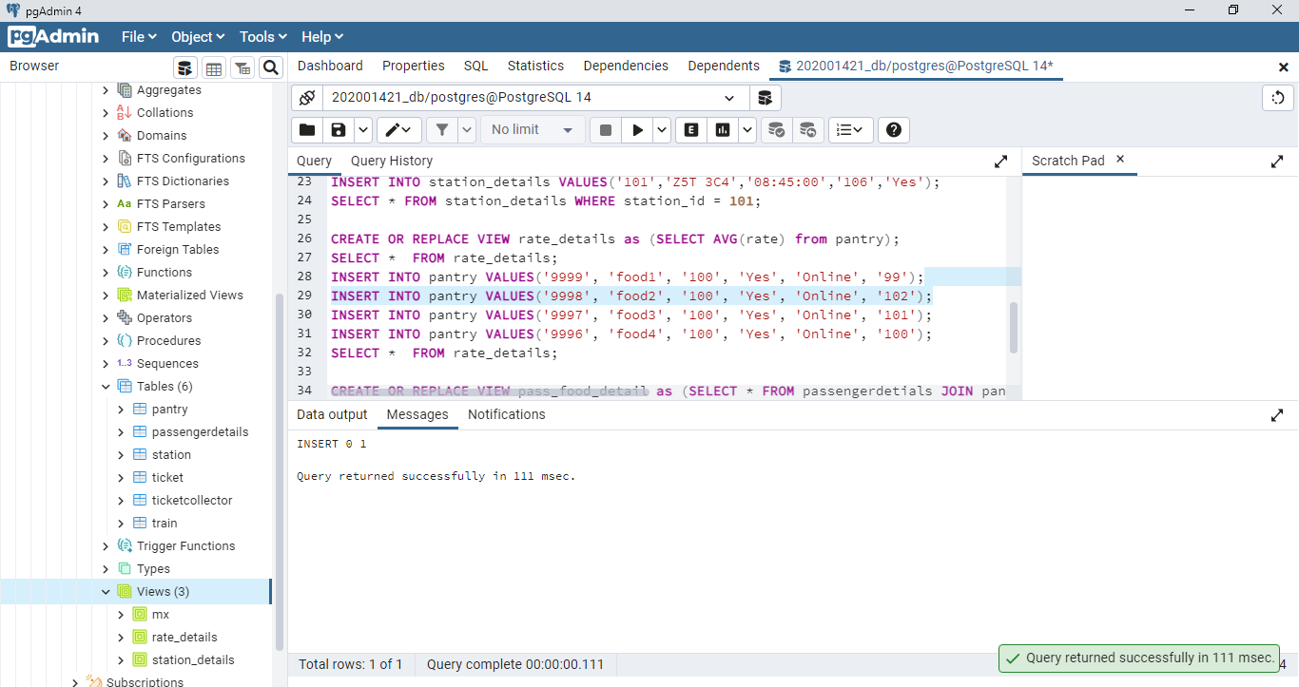
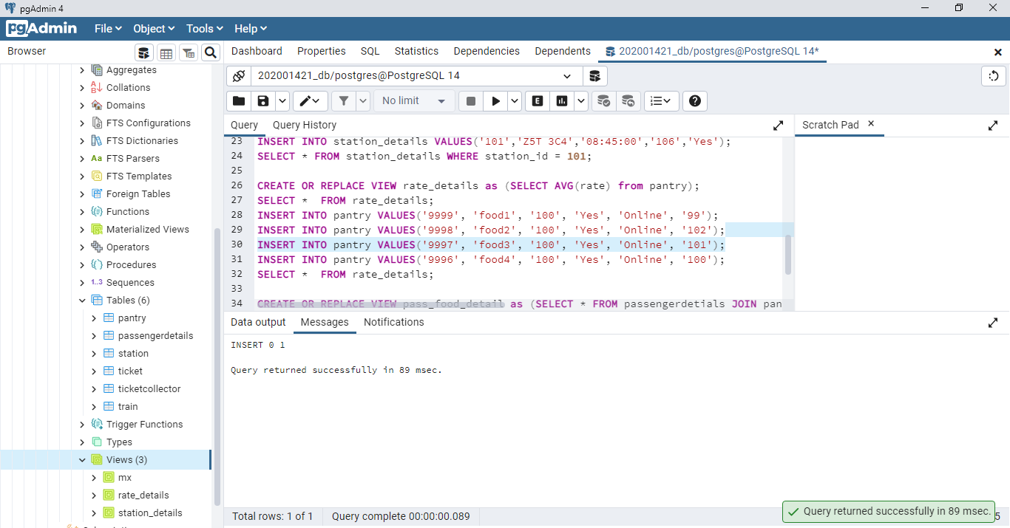
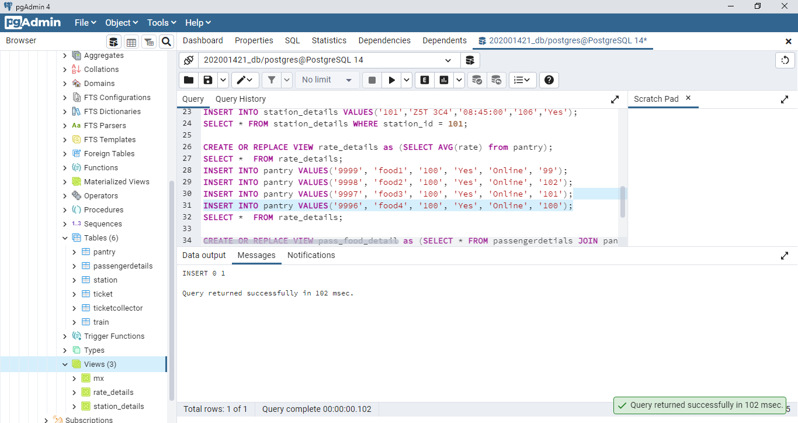
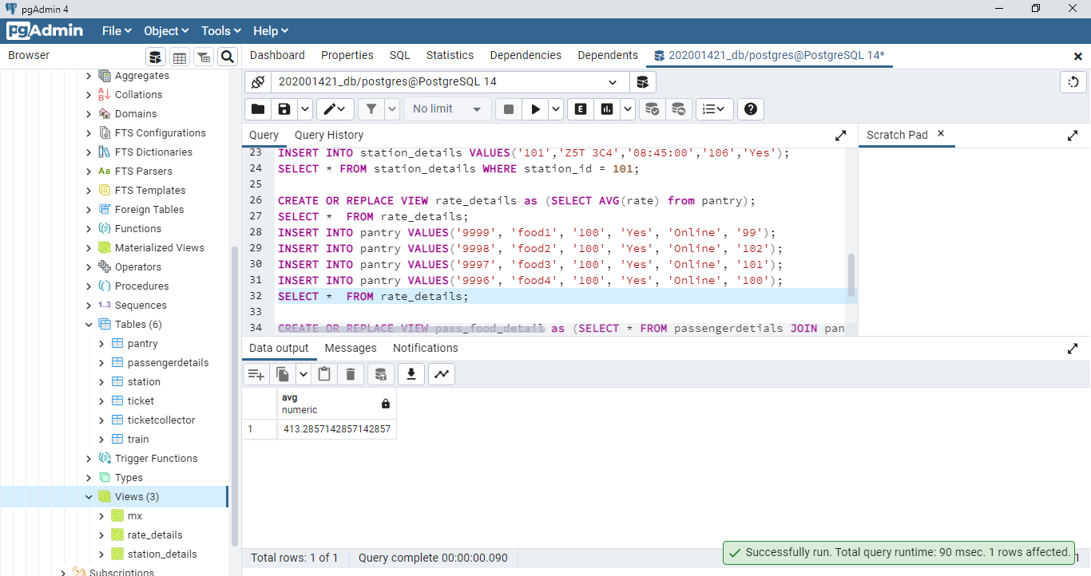

13: Create a view with all the train names and the station_id on which it is arriving in
ascending order of station id.
CREATE OR REPLACE VIEW train_stat_detail as (SELECT station_id, train_name FROM train JOIN station ON station.train_id = train.train_id);
SELECT * FROM train_stat_detail;
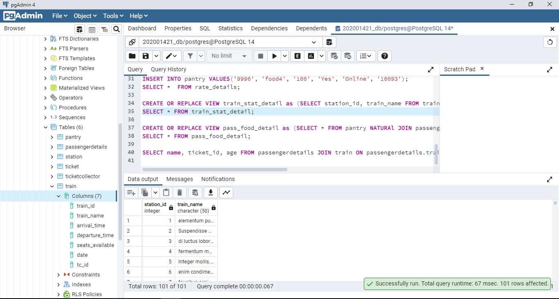

14: Display all the details of passengers whose payment mode was online for food items and create a view for the same.
CREATE OR REPLACE VIEW pass_food_detail as (SELECT * FROM pantry NATURAl JOIN passengerdetails WHERE payment_mode = 'Online' or payment_mode = 'online');
SELECT * FROM pass_food_detail;
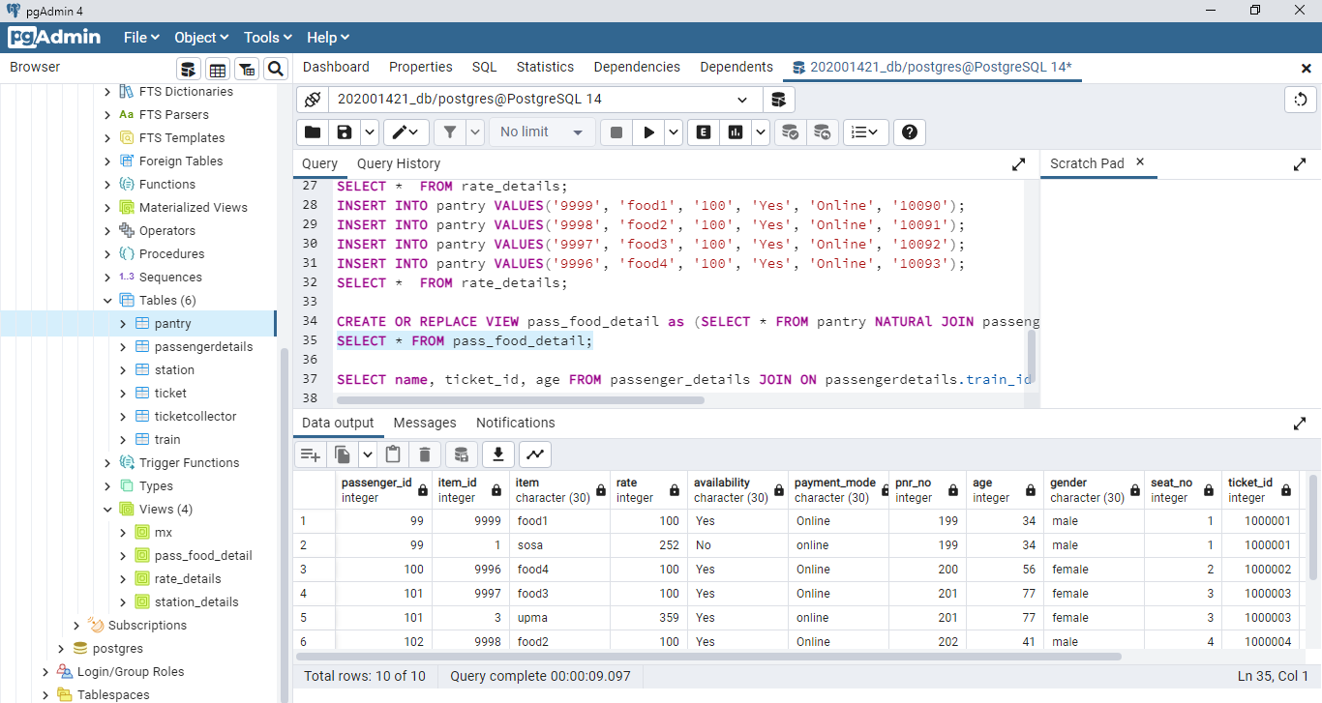
15: Display the name, ticket id and age of the passengers who are travelling in a train with the number of seats available is greater than 10 in decreasing order of the ticket id.

SELECT name, ticket_id, age FROM passengerdetails JOIN train ON passengerdetails.train_id = train.train_id WHERE train.seats_available > 10 ORDER BY ticket_id DESC;
